A

PROJECT REPORT
(Size 16 Times New Roman, Bold) (Line space= 1 line)
ON
(Size 16 Times New Roman, Bold )
(Line space=5 line)

TITLE OF PROJECT TOPIC

Submitted in partial fulfillment for the award of

Post Graduate Diploma in Advance Computing

(PG-DAC) from

INSTITUTE OF EMERGING TECHNOLOGIES

Authorized Training Centre


Under the Guidance of
Name of the Guide
(Size 16 Times New Roman, Bold )
(Line space=5 line)
BY
Name of student/s and Prn
( Size 16 Times New Roman, Bold)
(Line space=4 line)



CERTIFICATE
(Line space=1 line)

(Size 16 Times New Roman, Bold)

(Line space=4 line)

This is to certify that the project report entitled Hospital Management System is a bonfire work carried out by Virendra Sanjay Patil, Aashish Shishirkant Dahale, Prashant Ravindra Duse, Ajay Kavatekar and submitted in partial fulfilment of the requirement for the C-DAC ACTS, DAC course in Institute of Emerging Technology in the batch of Aug 2019.

Course Coordinator External Examiner

(Size 14 Times New Roman,bold )

ACKNOWLEDGEMENT
(Size 16 Times New Roman,bold )(Line space= 2 lines)

(Not more than 1 page in size 12 Times New Roman )

This project Hospital Management System was a great learning experience for us and we are submitting this work to Advanced Computing Training School (CDAC).

We are very glad to mention the Name of the Guid for her valuable guidance to work on this project. Her guidance and support helped us to overcome various obstacles and intricacies during the course of project work.

Our most heart full thanks goes to Mr. Sangram Patil (Director ,IET)who gave all the required support and kind coordination to provide all the necessities like required hardware , internet facility and extra lab hours to complete the project and throughout the course up to the last day here in C-DAC ACTS, Pune.

Sign of student
by
220945920114 Virendra Sanjay Patil
220945920025 Aashish Shishrkant Dahale
220945920031 Prashant Ravindra Duse
220945920006 Ajay Kavthekar

Abstract

Our project Hospital Management system includes registration of patients, storing their details into the system, and also booking their appointments with doctors. Our software has the facility to give a unique id for every patient and stores the details of every patient and the staff automatically. User can search availability of a doctor and the details of a patient using the id. The Hospital Management System can be entered using a username and password. It is accessible either by an administrator or receptionist. Only they can add data into the database. The data can be retrieved easily. The interface is very user-friendly. The data are well protected for personal use and makes the data processing very fast.

It is having mainly two modules. One is at Administration Level and other one is of user of patients and doctors. The Application maintains authentication in order to access the application. Administrator task includes managing doctor’s information, patient's information. To achieve this, aim a database was designed one for the patient and other for the doctors which the admin can access. The complaints which are given by user will be referred by authorities.

Index

Sr. No. | Title | Page No.
1 | Introduction
2 | Problem Definition & Scope
2.1 | Problem Definition
2.2 | Goals & Objectives
2.3 | Major Constraints& Outcomes
3 | Software Requirement Specification
3.1 | Purpose of System
3.2 | Scope
4 | System Modules
5 | Performance-Requirements
5.1 | H/W Requirements & S/W Requirements
6 | UML Diagram
6.1 | DFD
6.2 | ERD
6.3 | Use case diagram
6.4 | Class Diagram
6.5 | Sequence diagram
6.6 | Activity Diagram
6.7 | Deployment diagram
6.8 | System Architecture
7 | Test Cases
8 | Screenshots
9 | References

- Introduction
Our project Hospital Management system includes registration of patients, storing their disease details into the system. Our website has the facility to give a unique id for every patient and stores the details of every patient. The Hospital Management System can be used by entering respective username and password. It is accessible either by an administrator or receptionist. Only the respective person can add data in the database. The data can be retrieved easily. The interface is very user-friendly. The data are well protected and data processing is very fast, accurate and relevant.

- Problem Definition & Scope
Daily functions like patient registration, managing admission and overall management of various departments can be easily performed with higher accuracy after the installation of hospital website. The modules of hospital management website are user-friendly and easy to access.

  - Problem Definition
Hospital Management System can be used by entering respective username and password. It is accessible either by an administrator or receptionist. Only the respective person can add data in the database. The data can be retrieved easily. The interface is very user-friendly. The data is well protected and data processing is very fast, accurate and relevant. A hospital management system is a website designed to manage all the areas of a hospital such as medical, lab, beds, administrative and the corresponding processing of services.

  - Goals & Objectives
A hospital management system is a website designed to improve patient care and satisfaction by streamlining and automating administrative and medical processes in the hospital through an effective hospital management system.
This includes tracking patient information and medical records, scheduling appointments. The ultimate goal is to improve patient care and satisfaction, while also reducing costs and increasing efficiency. Provide a paper-less hospital up to 90%, excellent security of data at every level of user-system interaction and also provides robust & reliable storage and backup facilities.

  - Major Constraints& Outcomes
The Hospital Patient Management System is a self- contained system that manages activities of the hospital as bed assignment, personnel management, and administrative issues. Various stakeholders are involved in the hospital system.

- Software Requirement Specification

    - Functional Requirements:

● Adding Patients: The Hospital Management enables the staff at the front desk to include new patients in the system.
● Assigning an ID to the patients: The HMS enables the staff at the front desk to provide a unique ID for each patient and then add them to the record sheet of the patient. The patients can utilize the ID throughout their hospital stay.
● Deleting Patient ID: The staff in the administration section of the ward can delete the patient ID from the system when the patient checkout from the hospital.
● Adding to the beds available list: The Staff in the administration section of the ward can put the bed empty in the list of beds available.

Report Generation of HMS:
● Information of the Patient: The Hospital Management System generates a report on every patient regarding various information like patient’s name, Phone number, bed number, the doctor's name whom its assigns, ward name, and more.
● Availability of the Bed: The Hospital Management system also helps in generating reports on the availability of the bed regarding information like bed numbers unoccupied or occupied, ward name, and more.

Database of HMS:
● Mandatory Patient Information: Every patient has some necessary data like phone number, their first and last name, personal health number, postal code, country, address, city, 'patient's ID number, etc.
● Updating information of the Patient: The hospital management system enables users to update the information of the patient as described in the mandatory information included.

3.0.2 Non-Functional Requirements:
3.0.2.1 Security:
Patient Identification
The system requires the patient to identify himself /herself using PId
- Login ID
Any user who uses the system shall have a Logon ID and Password.
- Modification
Any modification (insert, delete, update) for the Database shall be synchronized and done only by the administrator in the ward.
- Front Desk staff Rights
Front Desk staff shall be able to view all information in HMS, add new patients to HMS but shall not be able to modify any information in it.
- Administrators' Rights
Administrators shall be able to view and modify all information in HMS.

3.0.2.2 Performance Requirements:
- Response Time
The system shall give responses in 1 second after checking the patient’s information.
- Capacity
The System must support 1000 people at a time.
- User-interface
The user-interface screen shall respond within 5 seconds.
- Conformity
The systems must conform to the Microsoft Accessibility guidelines

3.0.2.3 Maintainability:
- Errors
The system shall keep a log of all the errors.
3.0. Reliability:
Availability
The system shall be available all the time

  - Purpose System:
In corona crisis lots of people are died due to unavailability of beds and treatment we are tying to give direct bed availability count to the patient. This website will help the hospital to be more efficient in registration of their patients and manage appointments, records of patients. It enables doctors and admin to view patient report if required. The purpose of this project is to computerize all details regarding patient details and hospital details
  - Scope:
The website will be used as the application that serves hospitals, clinic, dispensaries or other health institutions. The intention of the system is to increase the number of patients that can be treated and managed properly. If the hospital management system is file based, management of the hospital has to put much effort on securing the files. They can be easily damaged by fire, insects and natural disasters. Also, could be misplaced by losing data and information.
We can save trees by using less paper, also the hassle of patient to visit hospitals for bed is reduced.

- System Modules:

Doctor Module:
• Add patients report
• Delete patients report
• Display reports
• Give prescriptions
• Search reports of patient

Receptionist Module:
• Add patient’s data
• Delete patient’s data
• Display records
• Refer to different doctors
• Search the record of patients

Patient Module:
The different functionalities of the module are listed below:
• Search reports
• Search his record

Lab Module:
The Lab technician is able to update reports.
• Add patient’s Reports

Bed Module:
The Receptionist is able to update bed availability.
• Add Bed Count

- Performance-Requirements:
Response Time: The system provides acknowledgment in just one second once the patient's information is checked.
● Capacity: The system needs to support at least 1000 people at once.
● User-Interface: The user interface acknowledges within five seconds.
● Conformity: The system needs to ensure that the guidelines of the Microsoft accessibilities are followed.

  - H/W Requirements & S/W Requirements:
5.1.1 H/W Requirement
- Core i5 processor
- 8 GB Ram.
- 20 GB of hard disk space in terminal machines
- 1 TB hard disk space in Server Machine
5.1.2 S/W Requirement:
- Windows 7 or above operating system
- JRE 1.8
- Mysql server

- UML Diagram:

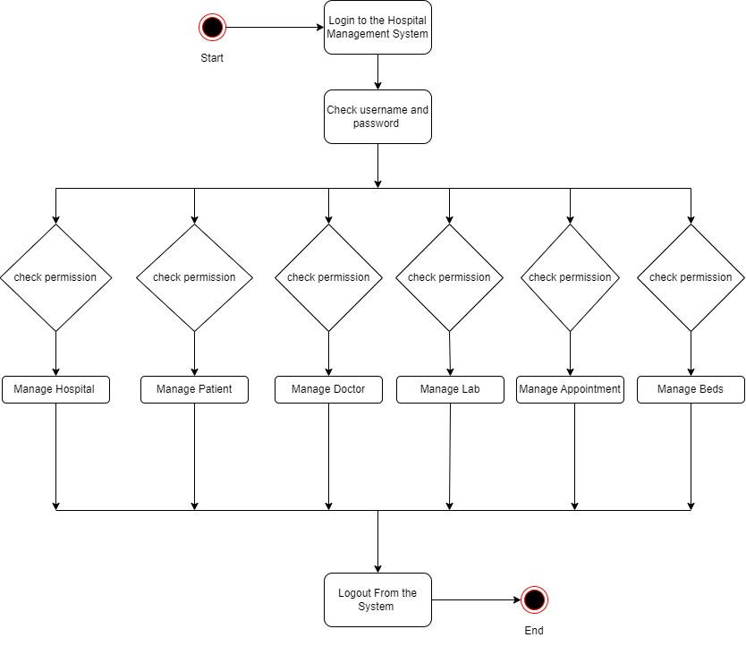

  - DFD:

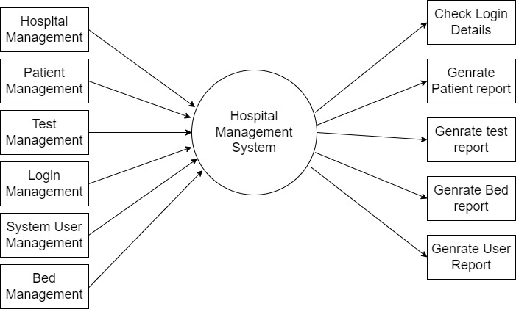

  - ERD
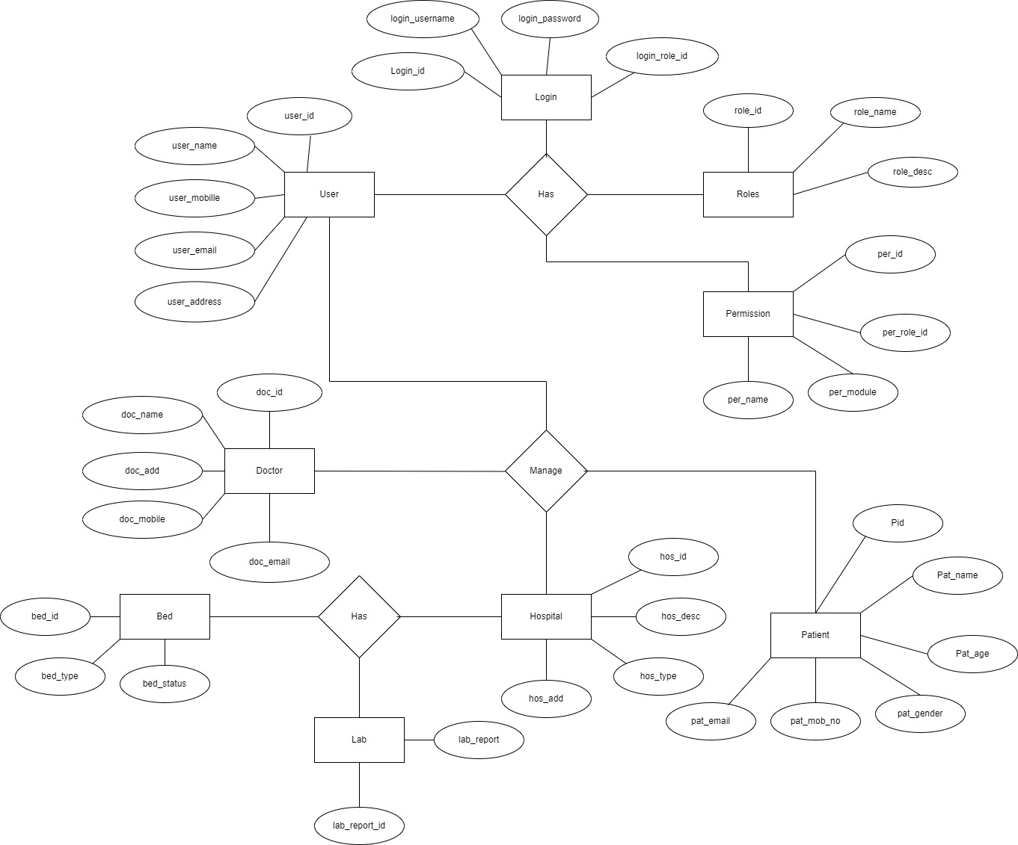
6.3 Use case diagram

